SWOT Analysis

Complete Study Notes for Management Students

Prepared for BBA | MBA | UGC NET | Competitive Examinations

Learning Objectives
After studying this chapter, learners will be able to:
- Understand the concept of SWOT Analysis.
- Explain each component of SWOT.
- Conduct a SWOT analysis for an organization.
- Differentiate between internal and external factors.
- Understand the advantages and limitations of SWOT.
- Apply SWOT analysis to business decision-making.
- Answer examination questions effectively.

1. Introduction
Every organization needs to understand where it stands before making strategic decisions. Managers must know:
- What are we good at?
- Where are we weak?
- What opportunities exist in the market?
- What threats may affect our business?
SWOT Analysis is one of the most widely used strategic planning tools that helps answer these questions.
It provides a structured framework for evaluating an organization's internal capabilities and the external business environment.

2. Definition of SWOT Analysis
SWOT Analysis is a strategic planning technique used to identify an organization's:
- Strengths
- Weaknesses
- Opportunities
- Threats
to formulate effective business strategies.
It combines the analysis of internal factors (Strengths and Weaknesses) with external factors (Opportunities and Threats).

3. Meaning of SWOT
Letter | Meaning | Nature
S | Strengths | Internal
W | Weaknesses | Internal
O | Opportunities | External
T | Threats | External

4. SWOT Matrix

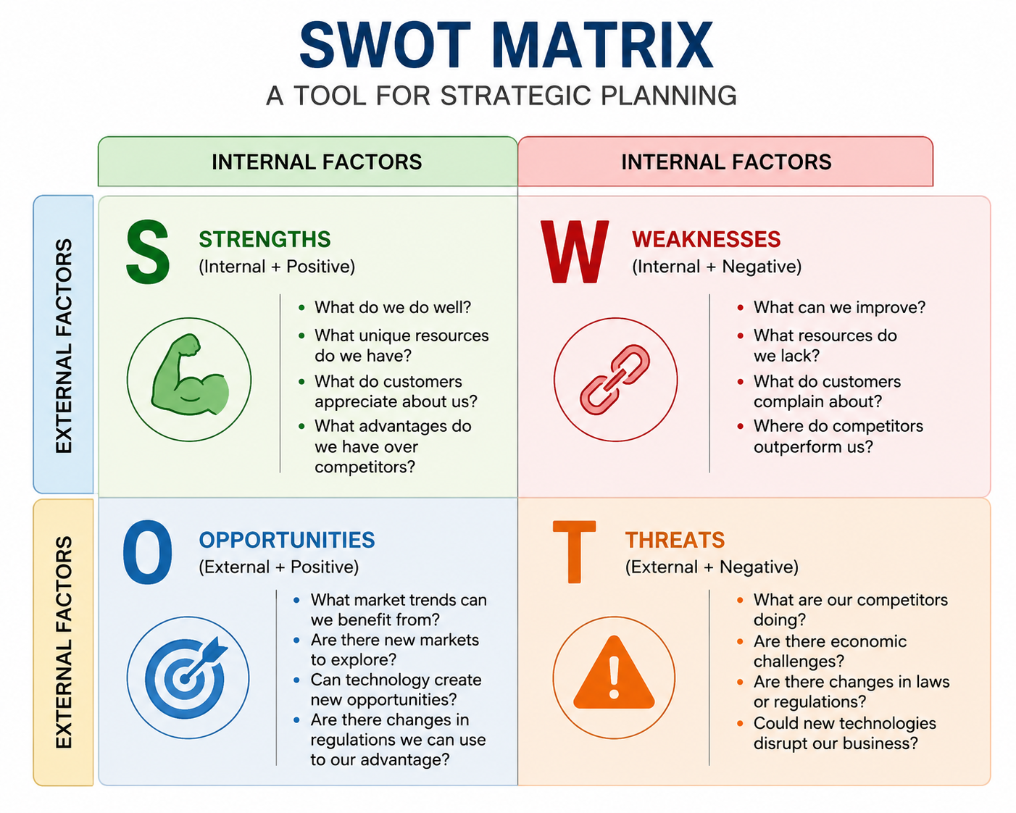

5. Components of SWOT Analysis

A. Strengths
Strengths are the internal capabilities and resources that give an organization a competitive advantage.

Examples
- Strong brand image
- Skilled employees
- High product quality
- Financial stability
- Advanced technology
- Loyal customers
- Efficient supply chain
- Patented products
- Strong leadership
- Excellent customer service

Questions to Identify Strengths
- What do we do better than competitors?
- What unique resources do we possess?
- Why do customers choose us?

B. Weaknesses
Weaknesses are internal limitations that reduce organizational performance.

Examples
- Limited financial resources
- Poor marketing
- High employee turnover
- Outdated technology
- Weak online presence
- Lack of innovation
- Poor customer service
- High production cost
- Inefficient management

Questions to Identify Weaknesses
- Where do we lack resources?
- What complaints do customers have?
- Which competitors outperform us?

C. Opportunities
Opportunities are favorable external conditions that can help an organization grow.

Examples
- Growing market demand
- Government incentives
- Technological advancements
- Expansion into new markets
- Rising disposable income
- New customer segments
- Strategic partnerships
- Digital transformation
- Export opportunities

Questions to Identify Opportunities
- Which market trends can benefit us?
- Are customer preferences changing?
- Can technology improve our operations?

D. Threats
Threats are external challenges that may negatively affect organizational performance.

Examples
- New competitors
- Economic recession
- Inflation
- Changing government regulations
- Substitute products
- Technological disruption
- Cybersecurity risks
- Supply chain disruptions
- Changing customer preferences

Questions to Identify Threats
- What external risks exist?
- Are competitors introducing better products?
- Are government policies changing?

6. Internal vs External Factors
Internal Factor | External Factors
Strengths | Opportunities
Weakness | Threats
Controlled by organization | Beyond direct control
Resources | Environment
Employees | Competitors
Technology | Government
Finance | Economy

7. SWOT Analysis Process

Step 1
Define the objective.
Example:
Increase market share.

Step 2
Identify strengths.

Step 3
Identify weaknesses.

Step 4
Identify opportunities.

Step 5
Identify threats.

Step 6
Develop strategic alternatives.

Step 7
Implement and monitor.

8. Example: SWOT Analysis of a Coffee Shop
Strengths | Weakness
Prime Location | Limited parking
Loyal customers | Small seating capacity
Quality coffee | Low advertising budget
Opportunities | Threats
Online delivery | New competitors
Rising coffee culture | Increasing raw material prices
Social media marketing | Economic slowdown

9. SWOT Analysis of Apple Inc.

Strengths
- Strong global brand
- Premium products
- Innovation
- Loyal customers
- Large cash reserves

Weaknesses
- Premium pricing
- Limited product customization
- High dependence on iPhone sales

Opportunities
- Artificial Intelligence
- Emerging markets
- Wearable devices
- Healthcare technology

Threats
- Intense competition
- Government regulations
- Counterfeit products
- Rapid technological change

10. SWOT Analysis of a Student

Strengths
- Good communication
- Time management
- Strong academic performance

Weaknesses
- Lack of practical experience
- Public speaking anxiety
- Limited technical skills

Opportunities
- Online certifications
- Internships
- Networking events
- AI learning platforms

Threats
- High competition
- Automation
- Economic uncertainty

11. Advantages of SWOT Analysis
- Simple and easy to understand.
- Supports strategic planning.
- Improves decision-making.
- Identifies competitive advantages.
- Encourages objective thinking.
- Helps allocate resources effectively.
- Applicable to businesses, institutions, and individuals.

12. Limitations of SWOT Analysis
- Subjective in nature.
- Does not prioritize factors.
- Provides a static view.
- No direct solution to problems.
- Depends on the quality of information.
- External factors change rapidly.

13. SWOT and Strategic Planning
SWOT Analysis acts as a bridge between environmental scanning and strategy formulation.
Managers use SWOT findings to:
- Develop business strategies.
- Enter new markets.
- Launch new products.
- Improve organizational performance.
- Gain competitive advantage.

14. Relationship with Other Strategic Tools
Tool | Purpose
SWOT | Overall strategic assessment
PESTLE | Macro-environment analysis
Porter’s Five Forces | Industry competition
Value Chain Analysis | Internal activities
VRIO | Competitive resources
BCG Matrix | Portfolio analysis
Ansoff Matrix | Growth strategies

15. TOWS Matrix (Advanced SWOT)
The TOWS Matrix extends SWOT by matching internal and external factors to generate strategic options.
Strategy | Description
SO Strategy | Use strengths to exploit opportunities
WO Strategy | Overcome weaknesses using opportunities
ST Strategy | Use strengths to reduce threats
WT Strategy | Minimize weaknesses and avoid threats

Example
SO: Use a strong brand to enter new international markets.
WO: Invest in digital marketing to overcome weak online visibility.
ST: Use advanced technology to compete against new entrants.
WT: Reduce costs and improve operational efficiency during an economic downturn.

16. Examination Tips
Remember:
S = Strengths (Internal + Positive)
W = Weaknesses (Internal + Negative)
O = Opportunities (External + Positive)
T = Threats (External + Negative)

17. Frequently Asked Examination Questions

Short Questions
- Define SWOT Analysis.
- Explain Strengths and Weaknesses.
- What are Opportunities?
- Differentiate between internal and external factors.
- State two advantages of SWOT.

Long Questions
- Explain SWOT Analysis with suitable examples.
- Discuss the components of SWOT Analysis.
- Evaluate the advantages and limitations of SWOT Analysis.
- Explain the TOWS Matrix with examples.
- Conduct a SWOT Analysis of a company of your choice.

18. Key Takeaways
- SWOT is a strategic planning framework.
- Strengths and Weaknesses are internal factors.
- Opportunities and Threats are external factors.
- SWOT supports strategic decision-making.
- The TOWS Matrix converts SWOT findings into actionable strategies.
- SWOT is most effective when combined with tools such as PESTLE and Porter's Five Forces.

References
- Kotler, P., & Keller, K. L. Marketing Management. Pearson.
- David, F. R., David, F. R., & David, M. E. Strategic Management: A Competitive Advantage Approach. Pearson.
- Wheelen, T. L., Hunger, J. D., Hoffman, A. N., & Bamford, C. E. Strategic Management and Business Policy. Pearson.
- Hill, C. W. L., Schilling, M. A., & Jones, G. R. Strategic Management: Theory. Cengage Learning.
- Johnson, G., Scholes, K., & Whittington, R. Exploring Strategy. Pearson.
- Barney, J. B., & Hesterly, W. S. Strategic Management and Competitive Advantage. Pearson.

